Relational Algebra-

Relational Algebra is a procedural query language which takes a relation as an input and generates a relation as an output.

Relational Algebra Operators-

The operators in relational algebra may be classified as-

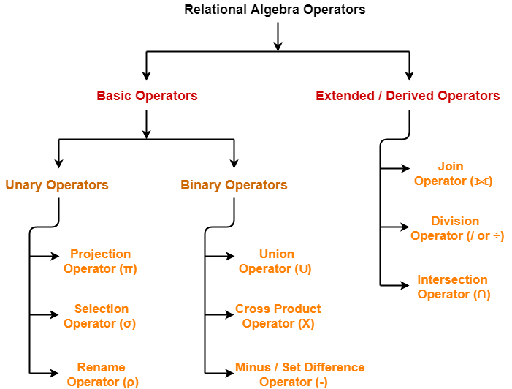

We will discuss all these operators one by one in detail.

Characteristics-

Following are the important characteristics of relational operators-

- Relational Operators always work on one or more relational tables.
- Relational Operators always produce another relational table.
- The table produced by a relational operator has all the properties of a relational model.

operators in relational algebra are classified as-

Selection Operator-

- Selection Operator (σ) is a unary operator in relational algebra that performs a selection operation.
- It selects those rows or tuples from the relation that satisfies the selection condition.

Syntax-

σ_{<selection_condition>}(R)

Examples-

- Select tuples from a relation “Books” where subject is “database”
σ_{subject = “database”} (Books)
- Select tuples from a relation “Books” where subject is “database” and price is “450”
σsubject = “database” ∧ price = “450” (Books)
- Select tuples from a relation “Books” where subject is “database” and price is “450” or have a publication year after 2010
σsubject = “database” ∧ price = “450” ∨ year >”2010″ (Books)

Important Points-

Point-01:

- We may use logical operators like ∧ , ∨ , ! and relational operators like = , ≠ , > , < , <= , >= with the selection condition.

Point-02:

- Selection operator only selects the required tuples according to the selection condition.
- It does not display the selected tuples.
- To display the selected tuples, projection operator is used.

Point-03:

- Selection operator always selects the entire tuple. It can not select a section or part of a tuple.

Point-04:

- Selection operator is commutative in nature i.e.
σ _{A ∧ B} (R) = σ _{B ∧ A} (R)
OR
σ _{B} (σ _{A}(R)) = σ _{A} (σ _{B}(R))

Point-05:

- Degree of the relation from a selection operation is same as degree of the input relation.

Point-06:

- The number of rows returned by a selection operation is obviously less than or equal to the number of rows in the original table.
Thus,
- Minimum Cardinality = 0
- Maximum Cardinality = |R|

Projection Operator-

- Projection Operator (π) is a unary operator in relational algebra that performs a projection operation.
- It displays the columns of a relation or table based on the specified attributes.

Syntax-

π_{<attribute list>}(R)

Example-

Consider the following Student relation-

ID | Name | Subject | Age
100 | Ashish | Maths | 19
200 | Rahul | Science | 20
300 | Naina | Physics | 20
400 | Sameer | Chemistry | 21

Student

Then, we have-

Result for Query π_{Name, Age}(Student)-

Name | Age
Ashish | 19
Rahul | 20
Naina | 20
Sameer | 21

Result for Query π_{ID , Name}(Student)-

ID | Name
100 | Ashish
200 | Rahul
300 | Naina
400 | Sameer

Important Points-

Point-01:

- The degree of output relation (number of columns present) is equal to the number of attributes mentioned in the attribute list.

Point-02:

- Projection operator automatically removes all the duplicates while projecting the output relation.
- So, cardinality of the original relation and output relation may or may not be same.
- If there are no duplicates in the original relation, then the cardinality will remain same otherwise it will surely reduce.

Point-03:

- If attribute list is a super key on relation R, then we will always get the same number of tuples in the output relation.
- This is because then there will be no duplicates to filter.

Point-04:

- Projection operator does not obey commutative property i.e.
π _{<list2>} (π _{<list1>} (R)) ≠ π _{<list1>} (π _{<list2>} (R))

Point-05:

- Following expressions are equivalent because both finally projects columns of list-1
π _{<list1>} (π _{<list2>} (R)) = π _{<list1>} (R)

Point-06:

- Selection Operator performs horizontal partitioning of the relation.
- Projection operator performs vertical partitioning of the relation.

Point-07:

- There is only one difference between projection operator of relational algebra and SELECT operation of SQL.
- Projection operator does not allow duplicates while SELECT operation allows duplicates.
- To avoid duplicates in SQL, we use “distinct” keyword and write SELECT distinct.
- Thus, projection operator of relational algebra is equivalent to SELECT operation of SQL.

Set Theory Operators-

Following operators are called as set theory operators-

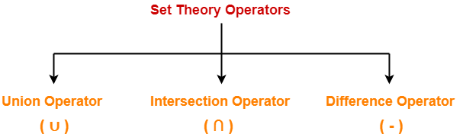

- Union Operator (∪)
- Intersection Operator (∩)
- Difference Operator (-)

Condition For Using Set Theory Operators

To use set theory operators on two relations,
The two relations must be union compatible.
Union compatible property means-
- Both the relations must have same number of attributes.
- The attribute domains (types of values accepted by attributes) of both the relations must be compatible.

Also read- Selection Operator and Projection Operator

1. Union Operator (∪)-

Let R and S be two relations.
Then-
- R ∪ S is the set of all tuples belonging to either R or S or both.
- In R ∪ S, duplicates are automatically removed.
- Union operation is both commutative and associative.

Example-

Consider the following two relations R and S-

ID | Name | Subject
100 | Ankit | English
200 | Pooja | Maths
300 | Komal | Science

Relation R

ID | Name | Subject
100 | Ankit | English
400 | Kajol | French

Relation S

Then, R ∪ S is-

ID | Name | Subject
100 | Ankit | English
200 | Pooja | Maths
300 | Komal | Science
400 | Kajol | French

Relation R ∪ S

2. Intersection Operator (∩)-

Let R and S be two relations.
Then-
- R ∩ S is the set of all tuples belonging to both R and S.
- In R ∩ S, duplicates are automatically removed.
- Intersection operation is both commutative and associative.

Example-

Consider the following two relations R and S-

ID | Name | Subject
100 | Ankit | English
200 | Pooja | Maths
300 | Komal | Science

Relation R

ID | Name | Subject
100 | Ankit | English
400 | Kajol | French

Relation S

Then, R ∩ S is-

ID | Name | Subject
100 | Ankit | English

Relation R ∩ S

3. Difference Operator (-)-

Let R and S be two relations.
Then-
- R – S is the set of all tuples belonging to R and not to S.
- In R – S, duplicates are automatically removed.
- Difference operation is associative but not commutative.

Example-

Consider the following two relations R and S-

ID | Name | Subject
100 | Ankit | English
200 | Pooja | Maths
300 | Komal | Science

Relation R

ID | Name | Subject
100 | Ankit | English
400 | Kajol | French

Relation S

Then, R – S is-

ID | Name | Subject
200 | Pooja | Maths
300 | Komal | Science

Relation R – S

